Frequencies

Notes

Statistics
Gender of the Respondent
N | Valid | 10
N | Missing | 0

Gender of the Respondent
 |  | Frequency | Percent | Valid Percent | Cumulative Percent
Valid | Male | 5 | 50.0 | 50.0 | 50.0
Valid | Female | 5 | 50.0 | 50.0 | 100.0
Valid | Total | 10 | 100.0 | 100.0

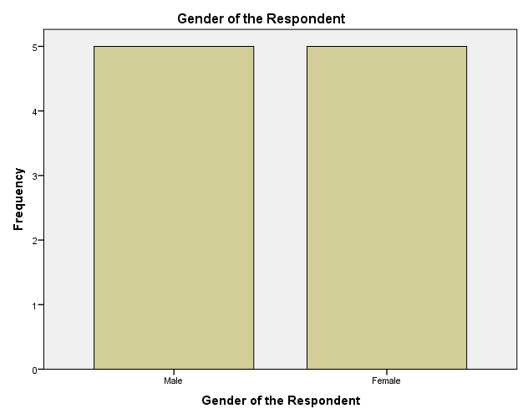

Frequencies

Statistics
Age of the Respondent
N | Valid | 10
N | Missing | 0

Age of the Respondent
 |  | Frequency | Percent | Valid Percent | Cumulative Percent
Valid | 18-24 | 2 | 20.0 | 20.0 | 20.0
Valid | 25-34 | 2 | 20.0 | 20.0 | 40.0
Valid | 35-44 | 2 | 20.0 | 20.0 | 60.0
Valid | 45-54 | 2 | 20.0 | 20.0 | 80.0
Valid | 55+ | 2 | 20.0 | 20.0 | 100.0
Valid | Total | 10 | 100.0 | 100.0

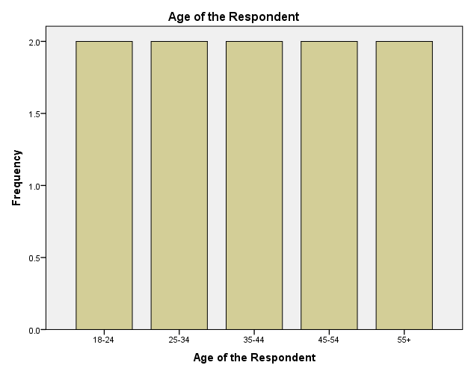

Frequencies

Statistics
Occupation of the Respondent
N | Valid | 10
N | Missing | 0

Occupation of the Respondent
 |  | Frequency | Percent | Valid Percent | Cumulative Percent
Valid | Employed | 4 | 40.0 | 40.0 | 40.0
Valid | Self Employed | 3 | 30.0 | 30.0 | 70.0
Valid | Claimant | 3 | 30.0 | 30.0 | 100.0
Valid | Total | 10 | 100.0 | 100.0

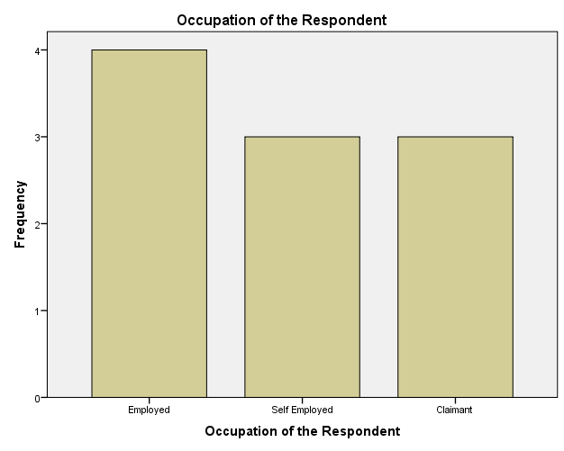

Frequencies

Statistics
Relationship to the Respondent
N | Valid | 10
N | Missing | 0

Relationship to the Respondent
 |  | Frequency | Percent | Valid Percent | Cumulative Percent
Valid | Self | 4 | 40.0 | 40.0 | 40.0
Valid | Family Member | 3 | 30.0 | 30.0 | 70.0
Valid | Friend | 3 | 30.0 | 30.0 | 100.0
Valid | Total | 10 | 100.0 | 100.0

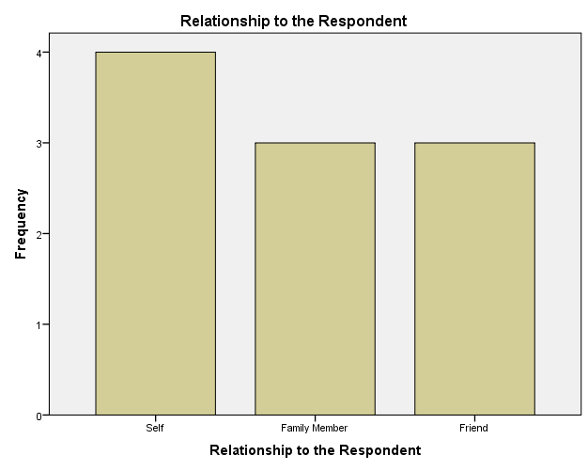

Frequencies

Statistics
Region of the Respondent
N | Valid | 10
N | Missing | 0

Region of the Respondent
 |  | Frequency | Percent | Valid Percent | Cumulative Percent
Valid | Nairobi | 2 | 20.0 | 20.0 | 20.0
Valid | Rift Valley | 2 | 20.0 | 20.0 | 40.0
Valid | Central/Eastern | 2 | 20.0 | 20.0 | 60.0
Valid | Nyanza/Western | 2 | 20.0 | 20.0 | 80.0
Valid | Coast/North Eastern | 2 | 20.0 | 20.0 | 100.0
Valid | Total | 10 | 100.0 | 100.0

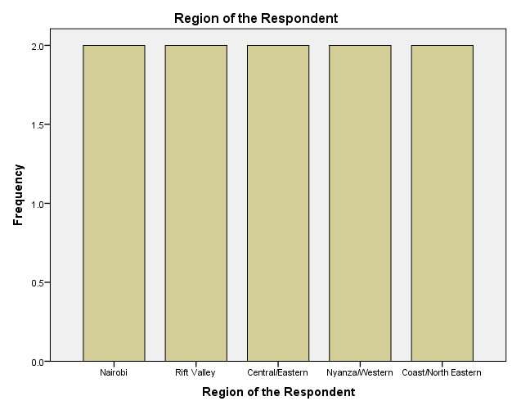

Multiple Response

Case Summary
 | Cases
 | Valid |  | Missing |  | Total
 | N | Percent | N | Percent | N | Percent
$Awareness_about_NSSFª | 10 | 100.0% | 0 | 0.0% | 10 | 100.0%

a. Dichotomy group tabulated at value 0.

$Awareness_about_NSSF Frequencies
 |  | Responses |  | Percent of Cases
 |  | N | Percent | Percent of Cases
Awareness about NSSFª | Respondents who heard about NSSF through Radio | 5 | 11.9% | 50.0%
Awareness about NSSFª | Respondents who heard about NSSF through TV | 5 | 11.9% | 50.0%
Awareness about NSSFª | Respondents who heard about NSSFthrough Newspaper | 5 | 11.9% | 50.0%
Awareness about NSSFª | Respondents who heard about NSSF through Friends/relatives/colleagues | 6 | 14.3% | 60.0%
Awareness about NSSFª | Respondents who heard about NSSF through Publicity Boards | 5 | 11.9% | 50.0%
Awareness about NSSFª | Respondents who heard about NSSF through the employer | 6 | 14.3% | 60.0%
Awareness about NSSFª | Respondents who heard about NSSF through visiting their premises | 5 | 11.9% | 50.0%
Awareness about NSSFª | Respondents who heard about NSSF through Other means | 5 | 11.9% | 50.0%
Total |  | 42 | 100.0% | 420.0%

a. Dichotomy group tabulated at value 0.

Multiple Response

Case Summary
 | Cases
 | Valid |  | Missing |  | Total
 | N | Percent | N | Percent | N | Percent
$NSSF_Benefitsª | 10 | 100.0% | 0 | 0.0% | 10 | 100.0%

a. Dichotomy group tabulated at value 0.

$NSSF_Benefits Frequencies
 |  | Responses |  | Percent of Cases
 |  | N | Percent | Percent of Cases
NSSF Benefitsª | Respondents who benefit from Retirement Benefit | 5 | 15.6% | 50.0%
NSSF Benefitsª | Respondents who benefit from Survival Benefit | 6 | 18.8% | 60.0%
NSSF Benefitsª | Respondents who benefit from Invalidity Benefit | 5 | 15.6% | 50.0%
NSSF Benefitsª | Respondents who benefit from Funeral Grant | 6 | 18.8% | 60.0%
NSSF Benefitsª | Respondents who benefit from Emigration Benefit | 4 | 12.5% | 40.0%
NSSF Benefitsª | Respondents who benefit from Withdrawal Benefit | 6 | 18.8% | 60.0%
Total |  | 32 | 100.0% | 320.0%

a. Dichotomy group tabulated at value 0.

Multiple Response

Case Summary
 | Cases
 | Valid |  | Missing |  | Total
 | N | Percent | N | Percent | N | Percent
$Awareness_about_NSSF_Benefitsª | 10 | 100.0% | 0 | 0.0% | 10 | 100.0%

a. Dichotomy group tabulated at value 0.

$Awareness_about_NSSF_Benefits Frequencies
 |  | Responses |  | Percent of Cases
 |  | N | Percent | Percent of Cases
Sources of Awareness about NSSF Benefitsª | Respondents who heard about NSSF benefits through Radio | 5 | 11.6% | 50.0%
Sources of Awareness about NSSF Benefitsª | Respondents who heard about NSSF benefits through the Television | 5 | 11.6% | 50.0%
Sources of Awareness about NSSF Benefitsª | Respondents who heard about NSSF benefits through Newspapers | 6 | 14.0% | 60.0%
Sources of Awareness about NSSF Benefitsª | Respondents who heard about NSSF benefits through Relatives/friend/colleagues | 6 | 14.0% | 60.0%
Sources of Awareness about NSSF Benefitsª | Respondents who heard about NSSF benefits through Public Boards | 6 | 14.0% | 60.0%
Sources of Awareness about NSSF Benefitsª | Respondents who heard about NSSF benefits through their Employer | 5 | 11.6% | 50.0%
Sources of Awareness about NSSF Benefitsª | Respondents who heard about NSSF benefits through NSSF Staff | 4 | 9.3% | 40.0%
Sources of Awareness about NSSF Benefitsª | Respondents who heard about NSSF benefits through Other means | 6 | 14.0% | 60.0%
Total |  | 43 | 100.0% | 430.0%

a. Dichotomy group tabulated at value 0.

Multiple Response

Case Summary
 | Cases
 | Valid |  | Missing |  | Total
 | N | Percent | N | Percent | N | Percent
$Satisfaction_Levelª | 10 | 100.0% | 0 | 0.0% | 10 | 100.0%

a. Dichotomy group tabulated at value 0.

$Satisfaction_Level Frequencies
 |  | Responses |  | Percent of Cases
 |  | N | Percent | Percent of Cases
Satisfaction Levelª | Level of Satisfaction on Distribution of NSSF Offices | 3 | 10.7% | 30.0%
Satisfaction Levelª | Level of Satisfaction on the Registration Process | 2 | 7.1% | 20.0%
Satisfaction Levelª | Level of Satisfaction on the Mode of Contribution | 2 | 7.1% | 20.0%
Satisfaction Levelª | Level of Satisfaction on the Affordability of Contribution | 3 | 10.7% | 30.0%
Satisfaction Levelª | Level of Satisfaction on the Contributions that enables Sufficient Income | 6 | 21.4% | 60.0%
Satisfaction Levelª | Level of Satisfaction on the Safety of the Contributions | 3 | 10.7% | 30.0%
Satisfaction Levelª | Level of Satisfaction on the NSSF Investments | 3 | 10.7% | 30.0%
Satisfaction Levelª | Level of Satisfaction NSSF Benefits compared to Competitors Benefits | 3 | 10.7% | 30.0%
Satisfaction Levelª | Level of Satisfaction on the decisions made by the NSSF Staff | 3 | 10.7% | 30.0%
Total |  | 28 | 100.0% | 280.0%

a. Dichotomy group tabulated at value 0.

Multiple Response

Case Summary
 | Cases
 | Valid |  | Missing |  | Total
 | N | Percent | N | Percent | N | Percent
$Level_of_Agreement_on_core_valuesª | 7 | 70.0% | 3 | 30.0% | 10 | 100.0%

a. Dichotomy group tabulated at value 0.

$Level_of_Agreement_on_core_values Frequencies
 |  | Responses |  | Percent of Cases
 |  | N | Percent | Percent of Cases
Level of Agreement on core values(staff)ª | Respondents who agree that NSSF doesn't tolerate corruption | 4 | 33.3% | 57.1%
Level of Agreement on core values(staff)ª | Respondents who agree that NSSF Staff comes up with better delivery services | 2 | 16.7% | 28.6%
Level of Agreement on core values(staff)ª | Respondents who agree that NSSF Staff should be responsible of their actions | 4 | 33.3% | 57.1%
Level of Agreement on core values(staff)ª | Respondents who agree that NSSF Staff works together to meet customers' demands | 2 | 16.7% | 28.6%
Total |  | 12 | 100.0% | 171.4%

a. Dichotomy group tabulated at value 0.

